Georgia State Parks and Historic Sites
Weekend Summary
06.08.2020

Crowds:
- Sites that had to temporarily limit day use access due to capacity include: Cloudland Canyon, Fort Yargo, Red Top Mountain, Rocky Mountain PFA, Sweetwater, Tallulah Gorge, Tugaloo and Vogel. The beach at Don Carter reached capacity and limited access both days.

- Although heavy rains on the coast throughout the weekend kept crowds down camping and cottages were at near capacity. Golf Course activity was still high this week although The Lakes at Laura Walker was much slower due to rain. Boat ramp activity was busy in most of the state.

- Gordonia and General Coffee had crowd size issues at the smaller picnic shelters this weekend.

- High Falls State Park had a yurt visitor complain about crowds at neighboring yurts. Park Staff and Monroe County SO spoke to this group and gained compliance.

Staffing issues:
- As of today, the Division has 50 part-time and full-time staff out due to COVID-19 related reasons. A total of 42 Camp Host Units (approximately 84 people) have left due to COVID-19 and 39 units have been replaced.

Positives
- As warmer weather has arrived, trail visitation is returning to normal levels at Red Top Mountain, Sweetwater Creek, and Fort Yargo; and overall visitation is leveling out at High Falls and Providence Canyon so that social distancing is not an issue.
- Brazel’s Creek received some good foot golf publicity this week.
- Fort Morris opened the museum with restricted access with good results.
- The Historic Naval Stores Museum, a small one room cabin interpreting the productions of turpentine in South Georgia, was moved to the Laura S. Walker this week.
- eRanger video series had 509 pageviews this past week (6/1-6/7) and the Facebook reach was 93,100 bringing the total since March 25th to 1,240,600.
- Website statistics continue to be high. This past week total Pageviews were up 94% YoY, Reservations pageviews were up 61% YoY, and the Alerts Page had 19,171. The Alerts page views pageviews. Since March 1- 441,074

Challenges
- Beach traffic and picnic shelter rentals are increasing which requires more social distancing management of park access.
- With high cottage use, and additional cleaning measures due to COVID-19, housekeeping is under extra pressure especially with turnovers. Richard Russell and Hard Labor Creek are working through staff shortages in housekeeping. Other staff and campground hosts are pitching in to clean cottages and keep up with the laundry.
- Red Top Mountain had an illegal camping issue on the Iron Hill trail that DNR LED assisted with. Red Top continues to have issues with roadside parking at the entrance to the beach and at the Bethany Bridge boat ramp.
- Fort Yargo had a day use restroom destroyed by vandals. Every sink, urinal, and toilet was busted.
- Tallulah Gorge had a rescue (walk out) on the stairs with LED handling citations in the gorge.
- At Cloudland Canyon and Tugaloo, they had intoxicated guests that were handled by local LE and LED.
- Staff at Fort McAllister requested help from the Bryan County Sheriff in the campground after a intoxicated woman assaulted her sister, brother-in-law, and nephew. She apparently left before they arrived, and they are looking for her.
- Chatham County Police escorted a couple off Skidaway following a loud, aggressive domestic argument.
- High Falls continues to deal with visitors getting on the falls. Park Staff have assigned a staff member to monitor the Falls Trail during peak visitation hours. High Falls also had items stolen from cars this past week. Monroe County SO is assisting in monitoring the park more closely.
- Sweetwater Creek had a guest faint on the red trail. Douglas Co. EMS, DNR LED, and park rangers responded. She is okay.
- The barn at Vaughters Farm was broken into. Park rangers found an area off the PATH trail where someone had driven down to the barn. Repairs are currently in progress and access to vehicles is being blocked.
- Watson Mill Bridge park rangers responded to an injured rider on the equestrian trail. She was brought back to a waiting ambulance with a dislocated or broken ankle. A group of day use riders rode their horses through the woods. Park rangers gave them verbal warnings/education for riding in an illegal area and alcohol. Law enforcement was unavailable to assist due to protests in Athens.
- Richard Russell had a report of illegal dumping of wastewater in the campground. DNR LED is investigating the incident.

Financial Update
Weekend Occupancy:
Our overall occupancy for all reservables increased 29% this past weekend to 76%. The weather this weekend last year was wet all across the state. Cottage rentals saw their 2nd weekend with an occupancy increase since COVID19 started. Cottage occupancy improved from 82% to 89%. This is 7% higher than last year. Camping continues to see high occupancy, reaching 85% this past weekend. This is up 34% from the same weekend last year. Yurt occupancy rebounded this past weekend to 92%, a 19% increase from the previous year.
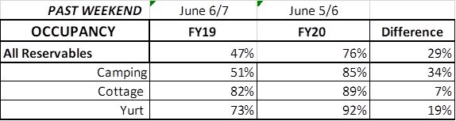

Upcoming Weekend:
For the upcoming weekend, we are seeing the same occupancy % as last year in all reservables at 73%. Camping is showing a 3% increase to 84%, but cottages and yurts are currently at a decrease from 2019. Cottages are showing a 6% decrease and yurts a 3% decrease to 96%.
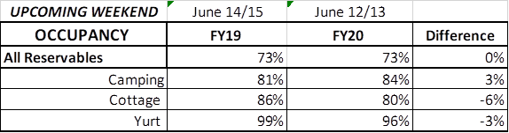
Revenue:
YTD thru June 7th, our park receipts have increased 6% or $1.8 Million. This past week, June 1st – 7th, there was a 37% or $318,000 increase in overall revenue. This is the 8th week in a row revenue has increased since the COVID situation began.
For overnight accommodations – camping revenue continues to increase. This past week camping improved 103% or $226,000. This is the 8th week in a row camping revenue has more than doubled. Cottages also saw a significant increase this past week of an 82% increase or $181,000; yurts improved 121% or $15,600.
This past week, ParkPass revenue increased 20% or $26,516 compared to last year.
Golf was up 69% this past week or $23,000.
The revenue continues to significantly improve over last week due to several reasons:
- In early April we changed policy from collecting only a one-night deposit when booking a reservation, to collecting all revenue at the time of booking. This is the reason for the significant increase to camping, cottage and yurt revenue. This will have an effect on future revenue collections and the amount of refunds given.
- Camping occupancy has actually improved over the previous year for the 8th weekend in a row. And cottage and yurt occupancy is improving as well.
- And again, the number of cancellations is starting to significantly slow down. Although we do need to keep in mind, that for future refunds, we will be refunding the revenue for the entire stay, rather than just a one-night deposit.

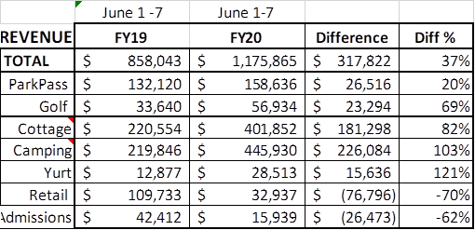
Cancellations/Refunds:
Through this morning, there has been 31,000 reservation cancellations, including $2.7 Million in actual refunds and a loss of future revenue of $11.5 Million.
This is 1,400 more than last Monday, when we were at 29,600 cancellations. The significant drop in the number of cancellations continues, as initially we had 4,000 – 5,000 a week, although we do still continue to see a higher number of cancellations than the previous year. Last year during the same week we had 1,200 cancellations, thus we had 200 more cancellations this past week than last year during the same time period.
Last year during March thru YTD, we had 11,375 cancellations, including $571,000 in actual refunds and a loss of future revenue of $2.7 Million.
So, total cancellations have increased over 19,625 or 172% and the amount of refunds have increased $2.1 Million.

